Task No & Title: | BSBCMN211A Participate in workplace safety procedures
Title: | Ergonomics Quiz ANSWERS
Suitable for Classes: | Certificate II Business Cert II in ICT
Area: | Technology & Enterprise
Teacher: | Mr Peter Faulks
Timeline | 2 hours
Date Due: | Today

Task Brief:
Files Required | Pen pencil only

Items highlighted in yellow are tasks for you to complete
Items in Blue are help tips

Ergonomic Quiz 2 Written Questions

Note Answers at end of this document

Select the alternative that correctly answers the following questions.

1 Who is considered most as risk from VDU radiation?

(a) Pregnant women
(b) Teachers
(c) Office staff
(d) Computer technicians

2 A small computer lab is set up as per the diagram below. What is the ergonomic disadvantage of this arrangement?
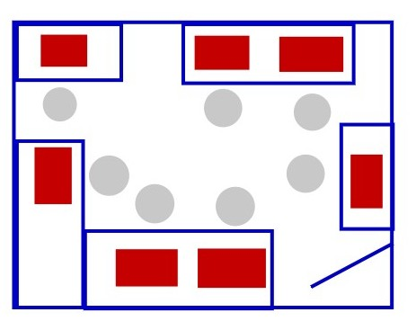
(a) Teacher can monitor each student.
(b) Middle of the room is open.
(c) No group discussion table.
(d) Students have to turn to watch the teacher.

3 When selecting computer tables which of the following features should NOT be considered?

(a) Provide enough working space
(b) Top should be laminated
(c) Should not be too low
(d) Allow access for people in wheelchairs

4 Keyboard drawers or trays are built into some workstations. Keyboard drawers are thought to be deficient in which area?

(a) Smaller keys
(b) No provision for a mouse
(c) More leg room
(d) Less noise
5 Which of the following is NOT a method that is used to help prevent carpal tunnel syndrome?

(a) Proper seating
(b) Adjustable table height
(c) Anti-glare screen
(d) Feet on the floor

6 Which of the following could be the cause of eyestrain at a computer workstation?

(a) Direct light source
(b) Anti-glare screen
(c) A computer hood
(d) Window treatments (curtains)

7 In most schools many students of different ages and sizes use computers – yet there are limited ergonomic factors implanted into computer labs. For many, it is cost related. Which of the following would be a cost effective solution to relieve this problem?

(a) Regular exercise breaks
(b) Implementing a laptop program
(c) Provide ergonomically designed rooms and workstations
(d) All of the above

8 What are the best features to look for when selecting an ergonomic chair?

(a) Lumber support and wheels
(b) Adjustability and cloth covered
(c) Padded back and arm rests
(d) Lumber support and adjustability.

9 To help prevent neck pain when working at a computer the top of the screen should be positioned so that it is:

(a) Above eye level
(b) Below eye level
(c) At or below eye level
(d) At or above eye level

10 Use the diagram below to decide which is the best location, ergonomically, for a computer to be placed.

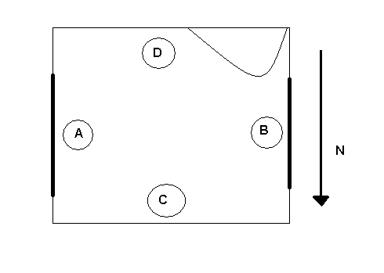
window
window
Door

(a) A
(b) B
(c) C
(d) D
True / False

1 Ergonomics is a science concerned chiefly with description and analysis of the production, distribution, and consumption of goods and services.

2 Reflected glare can be caused by shadows on the monitor.

3 When repeated stress is placed on tendons and muscles, this can result in a Cumulative Trauma Disorder.

4 Ergonomics is only a concern for people who work with computers.

5 If your wrists are at an angle when typing, then you should try putting the keyboard on your lap.

6 When working on a wireless LAN, users should avoid working where the radio waves are being transmitted.

7 The advantage of this type of computer room arrangement is that all students face the front.
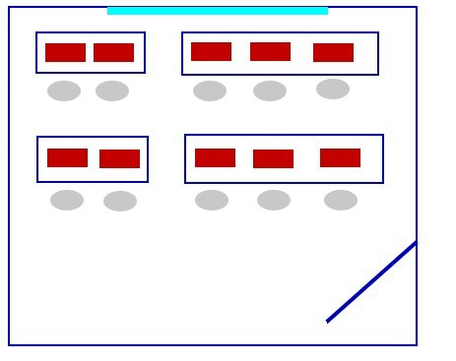

8 People who use laptop computers over extended periods of time should consider getting an external keyboard.

9 Armrests on chairs are designed to reduce loads on your spine.

10 A standard office desk would be appropriate for a computer workstation.

Match the Word to the Statement

A - RSI E - biomechanics

B - Workstation F - trackball

C - CTD’s G - posture

D - dvorak H - lumbar support

1 ____ A keyboard design where most commonly used letters are positioned under the user’s strongest fingers.

2 ____ An essential component for an ergonomic chair.

3 ____ The entire work area accessed by a worker when performing their job.

4 ____ Injuries that occur from repeated physical movements.

5 ____ Allows you to move the cursor, while keeping your arm in fixed position.

6 ____ This is a term used for injuries that occur over a period of time due to repeated trauma.

7 ____ The position of the body and its limbs.

8 ____ This is the study of the effect of forces on the human body in movement and at rest.

ANSWERS

1 (a) VDU’s or monitors give out radiation from the back and sides. It is considered that this radiation may be harmful to pregnant women.

Whilst it is not a high risk the potential is there if the equipment is not set up properly.

2 (d) If the teacher needs to demonstrate something to the class, or wishes to speak to the class, students on at least one side of the room will constantly have to turn around.

3 (b) Tables should be large enough to house all hardware as well as leave room for the user to work. The material that is used to cover the table is not a critical issue.

4 (b) Most keyboard drawers, because of their design, don’t allow for the mouse pad. Consequently, the mouse has to be operated on a different level to the keyboard.

5 (c) Carpal tunnel syndrome is a repetitive strain injury in the wrist/hand area.

Whilst the other three are all techniques used to prevent the syndrome using an anti-glare screen is not.

6 (a) Workstations should be positioned so that light sources do not reflect on the screen. This can be done by using curtains, cleaning the monitor and using anti-glare filters.

7 (a) The most cost effective, in fact free, would to provide students with regular exercise breaks, especially when they have to sit in front of a computer for long periods of the day.

The exercising may simple involve stretching or just taking a 5 minute break.

8 (d) Lumbar support helps reduce the stress on the spine.

It is most important that the seat height is adjustable as well as to be able to adjust the seat angle to accommodate the wide range of shapes and sizes of people.

9 (c) Research has shown that placing the monitor so that the top of the screen is at or below eye level should be effective in helping prevent neck pain.

The monitor should also be placed at approximately arms length from the user.

10 (c) Positions A and B are both placed under window which could result in glare coming from outside, causing eyestrain for the user.

Position D is placed behind the door, which may indicate a cramped working environment.

True / False

1 False
Ergonomics is the study of human work. It is concerned with putting human needs and capabilities at the focus of designing technological systems.

2 False
Reflected glare is caused by overhead lights and sunlight, which can cause bright spots/glare on the screen. Monitors should be placed to minimise these effects.

3 True
Cumulative Trauma Disorder is the name that is given to these types of ‘injuries’. Repetitive movements (typing, incorrect monitor placement), repeated use of force (typing) and working in an awkward position are conditions that may cause CTD’s.

4 False
Ergonomics is concern for all. Ergonomics is a science that is involved with matching the job with the worker.

5 False.
The correct position is that your wrists should not be at an angle when typing. To solve this problem it is better to raise or lower your chair so that your wrists are at the correct angle.

6 False
Wireless LANs operate at very low power and the radio wave signals are weak. They are well below the exposure limits set by safety standards.

7 True
Students will not have to turn to view the board. The arrangement also allows for more computers per given area and gives the teacher the option of placing their desk at either the front or back.

8 True
Laptop keyboards are generally a lot smaller than ‘normal’ keyboards and if these are used consistently it could lead to wrist injuries or cramps in the hands/fingers.

9 True
Armrests redistribute the weight of your upper body thus reducing the load on your upper body.

Armrests also reduce postural strain and muscle loads on the arms, shoulders and neck.

10 False
Standard office desks are generally higher than workstation desks/tables, therefore making the keyboard too high.

Match the Word to the Statement

1 D - dvorak
A keyboard design where most commonly used letters are positioned under the user’s strongest fingers.

2 H - lumbar support
An essential component for an ergonomic chair.

3 B - Workstation
The entire work area accessed by a worker when performing their job.

4 A - RSI
Injuries that occur from repeated physical movements.

5 F - trackball
Allows you to move the cursor, while keeping your arm in fixed position.

6 C - CTD’s
This is a term used for injuries that occur over a period of time due to repeated trauma.

7 G - posture
The position of the body and its limbs.

8 E - biomechanics
This is the study of the effect of forces on the human body in movement and at rest.

